
Mechanics of Material

Merged MEEN325
Lab Report
Water Tunnel
The PI honor pledge:
“I pledge that I have neither given nor received any unauthorized assistance on this laboratory report assignment”
Submitted To: Shrinivas Bojanampati
Report submission date: 28/11/2019
Submitted by: Group B
Student Name: | Student ID | Signature
Sultan Alzarooni | 100052093 | A
Haytham Imad | 100050152 | B
Abdulaziz Albluoshi | 100050151 | C
Ahmed Nasser | 100052099 | D

Outline

Objectives -----------------------------------------------------------------
Introduction ---------------------------------------------------------------
Experimental Set-up ------------------------------------------------------
Procedures -----------------------------------------------------------------
Results ----------------------------------------------------------------------
Discussion ------------------------------------------------------------------
Conclusion ------------------------------------------------------------------
References ------------------------------------------------------------------

Objective
- Understand the principles of laser Doppler Velocimetry (LDV)
- Measure the velocity of the flow downstream and upstream of circular cylinder.
- Obtain velocity profile of downstream and upstream of a circular cylinder.
- Determine the Reynolds number and Strouhal numbers.
- Estimate the drag on the cylinder.

Introduction
Laser Doppler velocimetry(LDV) is a technique of measuring the velocity of a flow based on measurements of light scattering which is caused by particles in the flow. It is primarily concerned with quantifying micro-structures of the flows that are subjected to obstacles within the flow field. This method can obtained the measurements of the kinematics of the fluid motion. For this method, the measurement of the fluid velocity is made at intersections of 2 laser beams focused at a point of interest in the flow field. This technique requires laser light since 2 beams must monochromatic and be coherent in order for the intersection beams to create an interference pattern which occurs within the fluid and it is documented with a camera focuses only on the region of interest. In respect of the wavelength of the incident beams and angles between the beams, the fringe patterns would be created with the spacing of
d =λ / (2sin(θ2))
Where d , the fringe pattern spacing, λ being the wavelength of the light of the laser, and θ being the angle between 2 laser beams. When the particle is moving through the laser beam are of intersection, the scattered light will have a different intensity and frequency than normal fringe patterns. The new frequency which is denoted by (ω) and is defined by the velocity of the particle and fringe space.

Experimental Set-up
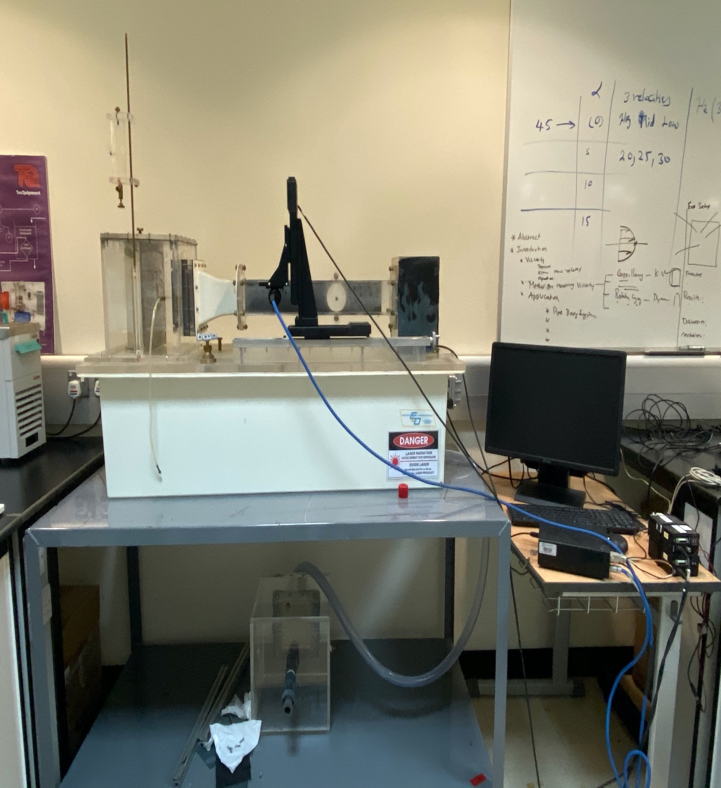
Dye Injector
Dye Valve
Head Tower
Control Valve
Water Reservoir
Contraction
Top Vent
Three-Axis Traverse
Weir Exit Plenum
Desk
Wall Plug w/ Airfoil
Interchangeable Test Section

Procedures

- Install the wall plug with the attached cylinder into the Interchangeable Model Test Section.
- Install the Interchangeable Model Test Section and Weir Exit Plenum into the Fluid Laboratory System. Ensure the wall plug is mounted in the wall opposite the MiniLDV sensor.
- Secure the flow and drain the Test Section.
- Remove the Wall Plug and measure the cylinder diameter with a calipers. Replace the Wall Plug.
- Start the submersible pump and establish desired flow by varying the valve.
- Setup the MiniLDV. Refer to Appendix B for operation of MiniLDV.
- Turn on the LDV system. Once the system is turned on and the BP software initialized, two red beams should be visible emerging from the probe and passing through the water tunnel test section.
- Run the NI scope and set proper Time period and Voltage. Doppler bursts should start appearing on the oscilloscope. Calculate the frequency from the plot on the scope and enter the frequency value into the software under Acquisition Expected Frequency
- Calculate the velocity of the flow using the frequency.

U = f * 3.52
Compare this value to the value of velocity generated using the software.

- Obtain the velocity profile by positioning the probe using the traverse at locations indicated in the Table 1 and establish the average freestream velocity by placing the probe.
- Acquire the data using Single Point Acquisition mode. Press Acquire button to record the data. Check the ‘Save’ checkbox to save the file. Record the values Ubar and U’ into the Table 1.
- Using the profile acquisition measure the velocity profile above and below the cylinder and record your data in Table 2.

Results

Discussion
The experimental outcomes show that in the upstream, where the velocity was above 0.30m/s, the distribution of the velocity was even. The characteristics of the flow can well be described by the frequency of the cut off. With a bigger flow the tube narrows the velocity variations in the measurement volumes. All the variations allowed the evaluations of particle velocity. The variation also gave insight for other characteristics. Observing the relative contribution of multiple scattering closely is one way of determining the particle densities. The non laminar flow which is connected to the spectrum can cause sudden widening of the peak. This makes the most important thing being to measure the particle velocities and compare them with the LDV results in order to gain more accurate and confident results.The signal can be made strong enough by using a more powerful laser to employ a pinhole and therefore increase the receiving optics resolution. The LDV can be used for broader applications by re-configuring the the setup for back-scattering. The LDV has a noninvasive nature and versatility which makes it an interesting method to perform experiments with.

Conclusion
The Upstream had a steady flow of velocity overtime and had intervals which are almost equal. At the start, the velocity of the Upstream was 0.24m/s and gradually increased resulting to a 0.37m/s finish. The Downstream had an unsteady flow of velocity with a starting point of 0.16m/s which gradually increase overtime with a 0.39m/s finish.Velocity from the bottom pipe surface to center of the cylinder Y direction started out at 0.21m/s velocity gradually increasing with a result of 0.4m/s at a distance of 25m.

References

